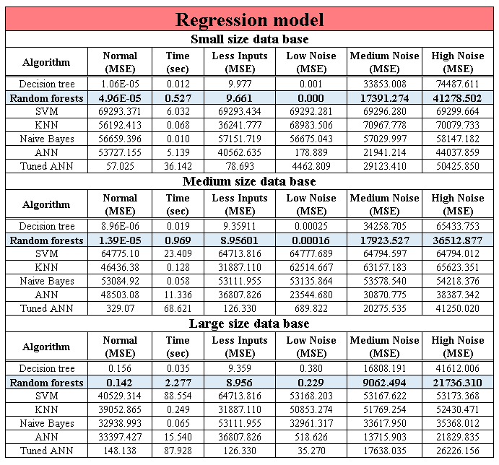

Table 3. Comparison of SML algorithms used to predict the electrical resistance variation using a regression model